CHAPTER-1

Introduction

In Plant Training (IPT)

In Plant Training will provide an industrial exposure to the students as well as to develop their career in the high tech industrial requirements. Reputed companies are providing in plant training to Students. Here students are initially get counseled in order to emerge out their interest in various streams and what are all the basic concepts they know on that domain.

After the successful completion of studies students has to face this competitive world with this knowledge to face many problems and to find the right solutions which is to be solved in the minimum duration of time. The in plant training is get totally different from the class environments.

**Need:-**

In-plant training **provides the industrial exposure** to the students how to face the industry once they put out from the campus. The **practical knowledge is essential** for all students to get success in their job. Once the student steps in to industry they should be ready to face competitive world with knowledge. The core competence area extending its boundary daily as technology grows. Students needs to update day to day stub from various innovative technologies. Job opportunity for students who has certificate on in-plant training is high compare to non-train students, because the company will know that student’s knowledge will be busted by in-plant training.

**Scope:-**

One objective of in-plant training is to help the student bridge the gap between academic theory and practical application and allow you the opportunity to explore a career in any field. To obtain knowledge of the organization structure and operations. To observe the conditions of the different departments and the opportunities those are available. IN-plant training provides opportunity to interact with people who have the inside track and chance to build network within industry. The main reason behind making a or researching this project is to know how the management works out to their employees and their main motto is that-

* Achieve goals
* Gain a positive perspective
* Create the power to change
* Build self-esteem and capability
* Manage their own development

**Objectives:-**

To get industry exposure.

* To work under factory discipline.
* To understand the psychology of the workers, their habits, attitudes and approach to problems along with the practices followed either at factory or at site.
* To get familiarized with various Design, Manufacturing, Analysis, Automation and Purchase, 5S, Six Sigma, TPM, Materials, Machines, Processes, Products and their applications along with relevant aspects of Industry management.
* To understand the scope, functions and job responsibilities in various departments of an organization

Benefits:-

* Watch how things work in industry.
* Know how the industry works.
* Learn the new technologies which in not part of academic syllabus.
* Know about the technologies used in the industry.
* Know about the future scope of the course.
* In-plant training will help students to get a job after graduation.
* In-plant training creates the opportunity for the students to explore their skills.

**Limitation**

* Generally the organization dose not allow outside to conduct any study or research work in the organization. Therefore, get the project done in the organization was very difficult.
* The time span for the project was very short which was of two months, which itself act as constraint, moreover, studying the guidelines and applied it practically with in such a short time span was a task of great pressure.

CHAPTER-2

Introduction to IOT

IOT (Internet of Things):-

“ The internet of things is a system of interrelated computing devices,mechanical and digital machines,objects,animal or people that are provides with unique identifiers and the ability to transfer data over a network without requiring human-to-human or human-to-computer interactions”,

The internet of Things(IOT) is a popular buzzword right now, but unlike many fads which have come and gone, the Internet of things describes an important trend which is having lasting effects on society at large. The term itself, ”Internet of things”, is used to mean a variety of ideas ,depending on the motivation and background of the speaker.

## **Components of IOT implementation**

* Sensors
* Networks
* Standards
* Intelligent Analysis
* Intelligent Action

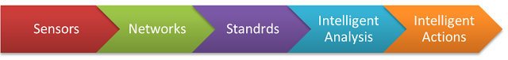

## **Sensors**

According to (IEEE) sensors can be defined as: An electronic device that produces electrical, optical, or digital data derived from a physical condition or event. Data produced from sensors is then electronically transformed, by another device, into information (output) that is useful in decision making done by “intelligent” devices or individuals (people).

### **Types of Sensors:**

### **Active Sensors & Passive Sensors**

The selection of sensors greatly impacted by many factors, including:

* Purpose (Temperature, Motion, Bio…etc.)
* Accuracy
* Reliability
* Range
* Resolution
* Level of Intelligence (dealing with noise and interference)

The driving forces for using sensors in IoT today are new trends in technology that made sensors cheaper, smarter and smaller.

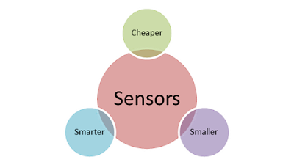

## **Networks**

The second step of this implantation is to transmit the signals collected by sensors over networks with all the different components of a typical network including routers, bridges in different topologies, including LAN, MAN and WAN.  Connecting the different parts of networks to the sensors can be done by different technologies including Wi-Fi, Bluetooth, Low Power Wi-Fi , Wi-Max, regular Ethernet , Long Term Evolution (LTE) and the recent promising technology of Li-Fi (using light as a medium of communication between the different parts of a typical network including sensors).

## **Standards**

The third stage in the implementation process includes the sum of all activities of handling, processing and storing the data collected from the sensors. This aggregation increases the value of data by increasing, the scale, scope, and frequency of data available for analysis but aggregation only achieved through the use of various standards depending on the IoT application in used.

## **Intelligent Analysis**

The fourth stage in IoT implementation is extracting insight from data for analysis, Analysis is driven by cognitive technologies and the accompanying models that facilitate the use of cognitive technologies.

## **Intelligent Actions**

Intelligent actions can be expressed as M2M and M2H interfaces for example with all the advancement in UI and UX technology

### **Factors driving adoption of intelligent actions within the IoT**

* Lower machine prices
* Improved machine functionality
* Machines “influencing” human actions through behavioural-science rationale
* Deep Learning tools

WHERE IS IOT?

It is everywhere

Examples:

Satellite ,highway tolls for tracking devices, vehicles, travelling using GPS, Home i.e. setup doxs, cc camera electronic gadgets etc, lower for measuring frequency ,medical purpose CR to measure heart beats laptops, smartphones, cooperate collages, organizations ,schools, solar, wind power, industries ,transport system etc;

It can be connected

*Satellite

* Gadgets like (fridge, TV, mobiles etc).
* Vehicles
* Amazon echo
* Most of the electronic device
* Scope is vat:

Everything is connected (mobile, Tv, watch etc..)

* Real-time alert:

Chemical reactors, blast furnace, nuclear reaction, human restricted areas.

**Raspberry Pi**

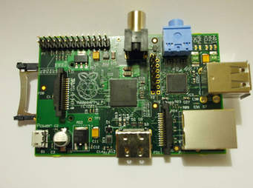

The **Raspberry Pi** is a series of small [single-board computers](https://en.wikipedia.org/wiki/Single-board_computer) developed in the [United Kingdom](https://en.wikipedia.org/wiki/United_Kingdom) by the [Raspberry Pi Foundation](https://en.wikipedia.org/wiki/Raspberry_Pi_Foundation)to promote teaching of basic [computer science](https://en.wikipedia.org/wiki/Computer_science) in schools and in [developing countries](https://en.wikipedia.org/wiki/Developing_countries).

 The original model became far more popular than anticipated, selling outside its [target market](https://en.wikipedia.org/wiki/Target_market) for uses such as [robotics](https://en.wikipedia.org/wiki/Robotics). It does not include peripherals (such as [keyboards](https://en.wikipedia.org/wiki/Keyboard_(computing)) and [mice](https://en.wikipedia.org/wiki/Mouse_(computing))) and [cases](https://en.wikipedia.org/wiki/Computer_case). However, some accessories have been included in several official and unofficial bundles.

The organisation behind the Raspberry Pi consists of two arms.

The first two models were developed by the [Raspberry Pi Foundation](https://en.wikipedia.org/wiki/Raspberry_Pi_Foundation). After the Pi Model B was released, the Foundation set up Raspberry Pi Trading, with [Eben Upton](https://en.wikipedia.org/wiki/Eben_Upton" \o "Eben Upton) as CEO, to develop the third model,

the B+. Raspberry Pi Trading is responsible for developing the technology while the Foundation is an educational charity to promote the teaching of basic computer science in schools and in developing countries

According to the Raspberry Pi Foundation, more than 5 million Raspberry Pis were sold by February 2015, making it the best-selling [British computer](https://en.wikipedia.org/wiki/British_computer).

 By November 2016 they had sold 11 million units,and 12.5m by March 2017, making it the third best-selling "general purpose computer".I In July 2017, sales reached nearly 15 million In March 2018, sales reached 19 million.

Device connected to sensors to measure temperature

Data can be stored parts:-

* USB power 5v,700ma
* HDMI vedio
* USB
* SD cards
* RJ 45 to connect ineternet or LAN connection
* Analong audio
* RCA vedio
* Phone for size comparision

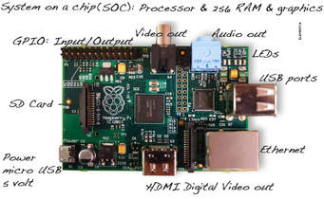

A Raspberry Pi is a credit card-sized computer originally designed for education, inspired by the 1981 BBC Micro. Creator Eben Upton's goal was to create a low-cost device that would improve programming skills and hardware understanding at the pre-university level. But thanks to its small size and accessible price, it was quickly adopted by tinkerers, makers, and electronics enthusiasts for projects that require more than a basic microcontroller (such as Arduino devices).

The Raspberry Pi is slower than a modern laptop or desktop but is still a complete Linux computer and can provide all the expected abilities that implies, at a low-power consumption level

Applications

AHC:-Automatic Hydrolic controller

Raspberry pi can be used in AHC in order to measure the frequency,amount of liquid present,capacity etc.

Top 6 Programming language for IOT

* PL: Programming language
* C:one of the most important language in IOT
* Java:is well-known programming language
* Javascript :used as a webprogramming language(servers,hubs)etc
* Swiff:if you want to interact with IOS devices with hubs
* Php:micro processor like servers (like polling GPS data from IOT devices)

CHAPTER-3

DEVOPS

Devops: As the word depicts, it was formed by combining two words: “development” and “operations”. DevOps is a collaborative way of developing and deploying software. DevOps (a portmanteau of development and operations) is a software development method that stresses communication, collaboration and integration between software developers and information technology (IT) operation professionals

Principals of devops:

• DevOps is an approach based on agile and lean principles in which business owners, development, operations, and quality assurance team collaborate to deliver software in a continuous stable manner

• DevOps is an environment that promotes cross practicality, shared business tasks and belief

•DevOps is a movement that improves IT service delivery agility

• DevOps is a culture that promotes better working relationship within the company

• DevOps is a set of practices that provides rapid, reliable software delivery

Benefit of devops

## 1. Shorter Development Cycles, Faster Innovation

## 2. Reduced Deployment Failures, Rollbacks, and Time to Recover

## 3. Improved Communication and Collaboration

## 4. Increased Efficiencies

## 5. Reduced Costs and IT Headcount

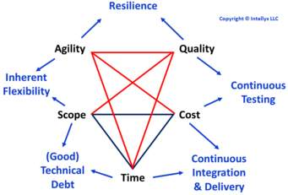

DEVOPS TOOLS COVERED

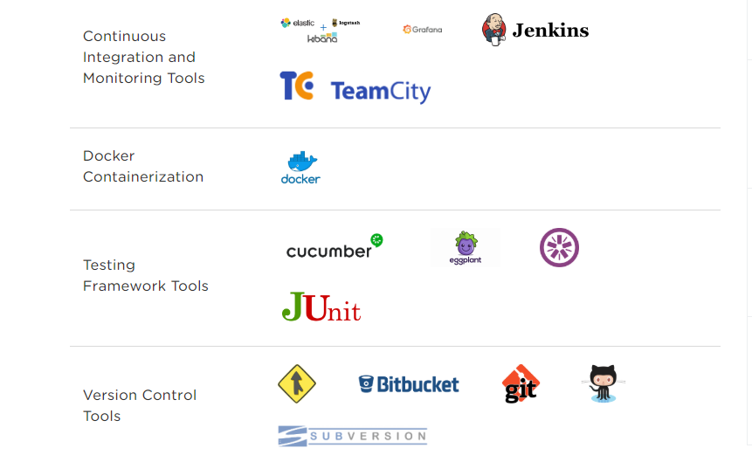

Advantages of using DevOps

The proven advantages of using DevOps are:

● Builds trust between the development and operations team which brings a change in the attitude towards pursuing the tasks.

● Improved value to the customer feedback with quick turnaround.

● Increase in efficiency, quality and reliability with the automation.

● Cost effective and speedy delivery of a product to market.

● Increase in the IT revenue.

Conclusion

In conclusion, DevOps is an approach that improves the collaboration between Development and Operations teams. Enabling DevOps improves the speed of the delivery according to the business and customer needs. Especially automation in DevOps improves the productivity, reliability and allows standardizing the process, which in turn plays a major role in product delivery for organizations. DevOps continues to be adapted by various organizations such as Facebook, Netflix, Walmart etc.

CHAPTER-4

SOFTSKILLS DEVELOPMENT TRAINNING

## What are Soft Skills?

Whereas hard skills are the tangible and technical skills easily demonstrated by a candidate’s qualifications and specific professional experiences, **soft skills** is a term used by employers to refer to the more intangible and non-technical abilities that are sought from candidates.

Soft skills are sometimes referred to as [**transferable skills**](https://www.wikijob.co.uk/content/interview-advice/competencies/transferable-skills) or **professional skills**. As this term implies, these are skills that are less specialised, less rooted in specific vocations, and more aligned with the general disposition and personality of a candidate. Examples of important soft skills are [communication](https://www.wikijob.co.uk/content/interview-advice/competencies/communication), [teamwork](https://www.wikijob.co.uk/content/interview-advice/competencies/teamwork) and [problem solving](https://www.wikijob.co.uk/content/interview-advice/competencies/problem-solving).

## What are the Key Soft Skills?

This section is an extensive, but not exhaustive, guide to what should be considered as some of the key soft skills:

*Communication

*Self-motivation

*Leadership

*Team work

*Resposiblity

*Problem solving

#### * Ability to Work Under Pressure and Time Management

* **Flexibility**

#### Communication

As a soft skill, [**communication**](https://www.wikijob.co.uk/content/interview-advice/competencies/communication) is not about multiple syllables or rousing speeches. Able communicators can adjust their tone and style according to their audience, comprehend and act efficiently on instructions, and explain complex issues to colleagues and clients alike. Communication is also an important aspect of leadership, since leaders must be able to delegate clearly and comprehensibly.

#### Self-Motivation

Having the **positive attitude** and the **initiative** to work well without round-the-clock supervision is a vital soft skill for any employee. Not only does it demonstrate reliability and commitment, but it shows that you can fit efficiently into an organisational structure without the need for constant oversight.

#### Leadership

[**Leadership**](https://www.wikijob.co.uk/content/interview-advice/competencies/leadership) is a soft skill you can show even if you’re not directly managing others. Leadership can be thought of as a collection of various other soft skills, such as a general positive attitude and outlook, the ability to communicate effectively, and an aptitude for both self-motivating and motivating others.

#### Responsibility

**Self-awareness** is a seldom talked about but highly valued soft skill; knowing when to accept responsibility for any mistakes you have made demonstrates a healthy level of humility, and a willingness to learn and progress.

#### Teamwork

Like leadership, good [**teamwork**](https://www.wikijob.co.uk/content/interview-advice/competencies/teamwork) involves a combination of other soft skills. Working in a team towards a common goal requires the intuition and interpersonal acumen to know when to be a leader, and when to be a listener. Good team players are perceptive, as well as receptive to the needs and responsibilities of others.

#### Problem Solving

[**Problem solving**](https://www.wikijob.co.uk/content/interview-advice/competencies/problem-solving) does not just require analytical, creative and critical skills, but a particular mindset: those who can approach a problem with a cool and level head will often reach a solution more efficiently than those who cannot. This is a soft skill which can often rely on strong [teamwork](https://www.wikijob.co.uk/content/interview-advice/competencies/teamwork) too. Problems need not always be solved alone. The ability to know who can help you reach a solution, and how they can do it, can be a great advantage.

Many jobs come with demanding deadlines and occasionally high stakes. Recruiters prize candidates who show a decisive attitude, an unfaltering ability to think clearly, and a capacity to compartmentalise and set stress aside. **Time management** is closely related to the ability to work under pressure, as well as within tight deadlines. Employees who manage their time well are able to efficiently prioritise tasks and organise their diaries, while adopting an attitude which allows them to take on new tasks and deadlines.

#### Flexibility

Naturally, people can be wary of leaving the comfort zone formed by their repertoire of hard skills. **Flexibility** is an important soft skill, inasmuch as it demonstrates an ability and willingness to acquire new hard skills, and an open-mindedness to new tasks and new challenges. Employers often seek candidates who can show a willing and upbeat attitude, since many jobs come with the possibility of secondments.

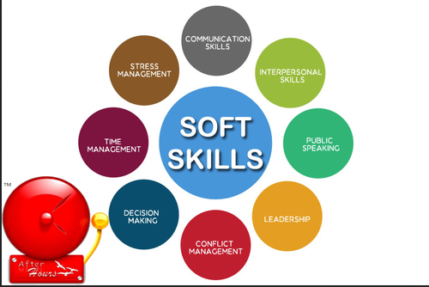

###### What is Group Discussion?

"Group" is a collection of individuals who have regular contact and frequent interaction and who work together to achieve a common set of goals. "Discussion" is the process whereby two or more people exchange information or ideas in a face-to-face situation to achieve a goal. The goal, or end product, maybe increased knowledge, agreement leading to action, disagreement leading to competition or resolution or perhaps only a clearing of the air or a continuation of the status-quo.



.

## WHAT IS A RESUME?

A resume is a short document used to summarize a job seeker’s experience and qualifications for a prospective employer. A resume includes the job seeker’s contact information, work experience, education, and relevant skills in support of a job application

HOW TO WRITE A RESUME?

*SELECT THE BEST RESUME TYPE

*MAKE IT LEGIABLE

*CONSISTENT

*KEEP IT FOCUSED

*GIVE IT A MAKECOVER

*USE RESUME EXAMPLES AND TEMPLATES

*GET CREATIVE

*CAREFULLY EDIT YOUR RESUME

HOW TO MAKE YOUR FIRST RESUME?

* [**Step 1:** Pick the Perfect Resume Format](https://resumegenius.com/how-to-write-a-resume#resume-format)

* [**Step 2:** Set Up Your Contact Information](https://resumegenius.com/how-to-write-a-resume#contact-information)

* * [**Step 3:** Select (and Write) a Winning Resume Introduction](https://resumegenius.com/how-to-write-a-resume#resume-introduction)
* * [**Step 4:** Highlight Your Relevant Work Experience](https://resumegenius.com/how-to-write-a-resume#work-experience)
* * [**Step 5:** Create a Pro Education Section](https://resumegenius.com/how-to-write-a-resume#education-section)
* * [**Step 6:** Use a Range of Hard & Soft Skills in Your Resume](https://resumegenius.com/how-to-write-a-resume#hard-soft-skills)
* * [**Step 7:** Tie in Key Certifications, Awards, and Honors](https://resumegenius.com/how-to-write-a-resume#additional-certs-awards)
* * [**Step 8:** Stylize Your Resume](https://resumegenius.com/how-to-write-a-resume#resume-style)
* * [**Step 9:** Write a Matching Cover Letter](https://resumegenius.com/how-to-write-a-resume#matching-cover-letter)
* * [**Step 10:** Proofread Your Resume & Finish Strong](https://resumegenius.com/how-to-write-a-resume#edit-proofread)

HOW TO WRITE AN INTERNSHIP RESUME?

EXAMPLE SHOWN BELOW:

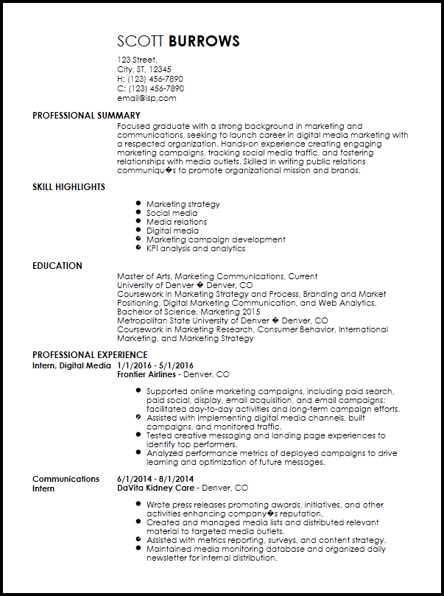

MOCK INTERVIEWS:

A mock interview, also known as a practice interview, is a simulation of an actual [job interview](https://www.thebalancecareers.com/what-to-expect-during-a-job-interview-2063897). It provides you with an opportunity to practice for an interview and receive feedback. A typical mock interview is a practice job interview held with a professional career counselor. A mock interview helps you learn how to answer difficult questions, develop interview strategies, improve your communication skills and reduce your stress before an actual job interview. During a mock interview, the interviewer may use a [semi-structured interview](https://www.thebalancecareers.com/what-is-a-semi-structured-interview-2061632) format rather than asking a formal list of questions.

Some of the main advantages of the mock interview are:

* It will reduce interview anxiety by familiarizing you with the situation.
* It will boost your confidence about the things you are doing well.
* It will allow you to preview any interviewing weaknesses you have.
* It gives you the opportunity to receive constructive feedback from an interviewing professional.

.

WHAT ARE THE QUESTIONS USUALLY ASKED IN INTERVIEWS

1. Can you tell me a little about yourself?

2. How did you hear about the position?

## 3. What do you know about the company?

## 4. Why do you want this job?

## 5. Why should we hire you?

## 6. What are your greatest professional strengths?

## 7. What do you consider to be your weaknesses?

## 8. What is your greatest professional achievement?

## 9. Tell me about a challenge or conflict you've faced at work, and how you dealt with it.

## 10. Where do you see yourself in five years?

## 11. What's your dream job?

## 12. What other companies are you interviewing with?

## 13. Why are you leaving your current job?

## 14. Why were you fired?

## 15. What are you looking for in a new position?

## 16. What type of work environment do you prefer?

## 17. What's your management style?

## 18. What's a time you exercised leadership?

## 19. What's a time you disagreed with a decision that was made at work?

## 20. How would your boss and co-workers describe you?

ANSWERS INRELATED TO THOSE QUESTIONS

## 1. Can you tell me a little about yourself?

This question seems simple, so many people fail to prepare for it, but it's crucial. Here's the deal: Don't give your complete employment (or personal) history. Instead give a pitch—one that’s concise and compelling and that shows exactly why you’re the right fit for the job. Start off with the 2-3 specific accomplishments or experiences that you most want the interviewer to know about, then wrap up talking about how that prior experience has positioned you for this specific role.

## 2. How did you hear about the position?

Another seemingly innocuous interview question, this is actually a perfect opportunity to stand out and show your passion for and connection to the company. For example, if you found out about the gig through a friend or professional contact, name drop that person, then share why you were so excited about it. If you discovered the company through an event or article, share that. Even if you found the listing through a random job board, share what, specifically, caught your eye about the role.

## 3. What do you know about the company?

Any candidate can read and regurgitate the company’s “About” page. So, when interviewers ask this, they aren't necessarily trying to gauge whether you understand the mission—they want to know whether you care about it. Start with one line that shows you understand the company's goals, using a couple key words and phrases from the website, but then go on to make it personal. Say, “I’m personally drawn to this mission because…” or “I really believe in this approach because…” and share a personal example or two.

## 4. Why do you want this job?

Again, companies want to hire people who are passionate about the job, so you should have a great answer about why you want the position. (And if you don't? You probably should apply elsewhere.) First, identify a couple of key factors that make the role a great fit for you (e.g., “I love customer support because I love the constant human interaction and the satisfaction that comes from helping someone solve a problem"), then share why you love the company (e.g., “I’ve always been passionate about education, and I think you guys are doing great things, so I want to be a part of it”).

## 5. Why should we hire you?

This interview question seems forward (not to mention intimidating!), but if you're asked it, you're in luck: There's no better setup for you to sell yourself and your skills to the hiring manager. Your job here is to craft an answer that covers three things: that you can not only do the work, you can deliver great results; that you'll really fit in with the team and culture; and that you'd be a better hire than any of the other candidates.

## 6. What are your greatest professional strengths?

When answering this question, interview coach Pamela Skillings recommends being accurate (share your true strengths, not those you think the interviewer wants to hear); relevant (choose your strengths that are most targeted to this particular position); and specific (for example, instead of “people skills,” choose “persuasive communication” or “relationship building”). Then, follow up with an example of how you've demonstrated these traits in a professional setting.

## 7. What do you consider to be your weaknesses?

What your interviewer is really trying to do with this question—beyond identifying any major red flags—is to gauge your self-awareness and honesty. So, “I can't meet a deadline to save my life” is not an option—but neither is “Nothing! I'm perfect!” Strike a balance by thinking of something that you struggle with but that you’re working to improve. For example, maybe you’ve never been strong at public speaking, but you've recently volunteered to run meetings to help you be more comfortable when addressing a crowd.

## 8. What is your greatest professional achievement?

Nothing says “hire me” better than a track record of achieving amazing results in past jobs, so don't be shy when answering this interview question! A great way to do so is by using the S-T-A-R method: Set up the situation and the task that you were required to complete to provide the interviewer with background context (e.g., “In my last job as a junior analyst, it was my role to manage the invoicing process”), but spend the bulk of your time describing what you actually did (the action) and what you achieved (the result). For example, “In one month, I streamlined the process, which saved my group 10 man-hours each month and reduced errors on invoices by 25%.”

## 9. Tell me about a challenge or conflict you've faced at work, and how you dealt with it.

In asking this [behavioral interview question](https://www.themuse.com/advice/30-behavioral-interview-questions-you-should-be-ready-to-answer), “your interviewer wants to get a sense of how you will respond to conflict. Anyone can seem nice and pleasant in a job interview, but what will happen if you’re hired and Gladys in Compliance starts getting in your face?” says Skillings. Again, you'll want to use the [S-T-A-R method](https://www.themuse.com/advice/star-interview-method), being sure to focus on how you handled the situation professionally and productively, and ideally closing with a happy ending, like how you came to a resolution or compromise.

## 10. Where do you see yourself in five years?

If asked this question, be honest and specific about your future goals, but consider this: A hiring manager wants to know a) if you've set realistic expectations for your career, b) if you have ambition (a.k.a., this interview isn't the first time you're considering the question), and c) if the position aligns with your goals and growth. Your best bet is to think realistically about where this position could take you and answer along those lines. And if the position isn’t necessarily a one-way ticket to your aspirations? It’s OK to say that you’re not quite sure what the future holds, but that you see this experience playing an important role in helping you make that decision.

## 11. What's your dream job?

Along similar lines, the interviewer wants to uncover whether this position is really in line with your ultimate career goals. While “an NBA star” might get you a few laughs, a better bet is to talk about your goals and ambitions—and why this job will get you closer to them.

## 12. What other companies are you interviewing with?

Companies ask this for a number of reasons, from wanting to see what the competition is for you to sniffing out whether you're serious about the industry. “Often the best approach is to mention that you are exploring a number of other similar options in the company's industry,” says job search expert Alison Doyle. “It can be helpful to mention that a common characteristic of all the jobs you are applying to is the opportunity to apply some critical abilities and skills that you possess. For example, you might say 'I am applying for several positions with IT consulting firms where I can analyze client needs and translate them to development teams in order to find solutions to technology problems.'”

## 13. Why are you leaving your current job?

This is a toughie, but one you can be sure you'll be asked. Definitely keep things positive—you have nothing to gain by being negative about your past employers. Instead, frame things in a way that shows that you're eager to take on new opportunities and that the role you’re interviewing for is a better fit for you than your current or last position. For example, “I’d really love to be part of product development from beginning to end, and I know I’d have that opportunity here.” And if you were let go? Keep it simple: “Unfortunately, I was let go,” is a totally OK answer.

## 14. Why were you fired?

OK, if you get the admittedly much tougher follow-up question as to whyyou were let go (and the truth isn't exactly pretty), your best bet is to be honest (the job-seeking world is small, after all). But it doesn't have to be a deal-breaker. Share how you’ve grown and how you approach your job and life now as a result. If you can position the learning experience as an advantage for this next job, even better.

## 15. What are you looking for in a new position?

Hint: Ideally the same things that this position has to offer. Be specific.

## 16. What type of work environment do you prefer?

Hint: Ideally one that's similar to the environment of the company you're applying to. Be specific.

## 17. What's your management style?

The best managers are strong but flexible, and that's exactly what you want to show off in your answer. (Think something like, “While every situation and every team member requires a bit of a different strategy, I tend to approach my employee relationships as a coach...”) Then, share a couple of your best managerial moments, like when you grew your team from five to 15 or coached an underperforming employee to become the company's top salesperson.

## 18. What's a time you exercised leadership?

Depending on what's more important for the role, you'll want to choose an example that showcases your project management skills (spearheading a project from end to end, juggling multiple moving parts) or one that shows your ability to confidently and effectively rally a team. And remember: “The best stories include enough detail to be believable and memorable,” says Skillings. “Show how you were a leader in this situation and how it represents your overall leadership experience and potential.”

## 19. What's a time you disagreed with a decision that was made at work?

Everyone disagrees with the boss from time to time, but in asking this interview question, hiring managers want to know that you can do so in a productive, professional way. “You don’t want to tell the story about the time when you disagreed but your boss was being a jerk and you just gave in to keep the peace. And you don’t want to tell the one where you realized you were wrong,” says Peggy McKee of Career Confidential. “Tell the one where your actions made a positive difference on the outcome of the situation, whether it was a work-related outcome or a more effective and productive working relationship.”

## 20. How would your boss and co-workers describe you?

First of all, be honest (remember, if you get this job, the hiring manager will be calling your former bosses and co-workers!). Then, try to pull out strengths and traits you haven't discussed in other aspects of the interview, such as your strong work ethic or your willingness to pitch in on other projects when needed.

CHAPTER-5

LIFE CYCLE OF PROJECT AND MANGEMENT OF LIFE CYCLE

a project is **unique** in that it is not a routine operation, but a specific set of operations designed to accomplish a singular goal. So a project team often includes people who don’t usually work together – sometimes from different organizations and across multiple geographies.

The development of software for an improved business process, the construction of a building or bridge, the relief effort after a natural disaster, the expansion of sales into a new geographic market — all are projects.

And all must be expertly managed to deliver the on-time, on-budget results, learning and integration that organizations need.

**Project management**, then, is the application of knowledge, skills, tools, and techniques to project activities to meet the project requirements.

It has always been practiced informally, but began to emerge as a distinct profession

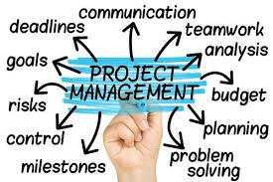

**Project management processes fall into five groups:**

1. Initiating
2. Planning
3. Executing
4. Monitoring and Controlling
5. Closing

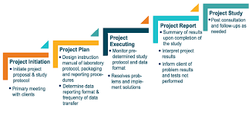

## 1. [Project Initiation](https://www.villanovau.com/resources/project-management/pmbok-initiating-process-group/)

Initiation is the first phase of the project lifecycle. This is where the project’s value and feasibility are measured. Project managers typically use two evaluation tools to decide whether or not to pursue a project:

* **Business Case Document** – This document justifies the need for the project, and it includes an estimate of potential financial benefits.
* **Feasibility Study** – This is an evaluation of the project’s goals, timeline and costs to determine if the project should be executed. It balances the requirements of the project with available resources to see if pursuing the project makes sense.

Teams abandon proposed projects that are labeled unprofitable and/or unfeasible. However, projects that pass these two tests can be assigned to a project team or designated project office.

## 2. [Project Planning](https://www.villanovau.com/resources/project-management/pmbok-planning-process-group/)

Once the project receives the green light, it needs a solid plan to guide the team, as well as keep them on time and on budget. A well-written project plan gives guidance for obtaining resources, acquiring financing and procuring required materials. The project plan gives the team direction for producing quality outputs, handling risk, creating acceptance, communicating benefits to stakeholders and managing suppliers.

The project plan also prepares teams for the obstacles they might encounter over the course of the project, and helps them understand the cost, scope and timeframe of the project.

## 3. [Project Execution](https://www.villanovau.com/resources/project-management/pmbok-executing-process-group/)

This is the phase that is most commonly associated with project management. Execution is all about building deliverables that satisfy the customer. Team leaders make this happen by allocating resources and keeping team members focused on their assigned tasks.

Execution relies heavily on the planning phase. The work and efforts of the team during the execution phase are derived from the project plan.

## 4. [Project Monitoring and Control](https://www.villanovau.com/resources/project-management/pmbok-monitoring-controlling-process-group/)

Monitoring and control are sometimes combined with execution because they often occur at the same time. As teams execute their project plan, they must constantly monitor their own progress.

To guarantee delivery of what was promised, teams must monitor tasks to prevent scope creep, calculate key performance indicators and track variations from allotted cost and time. This constant vigilance helps keep the project moving ahead smoothly.

## 5. [Project Closure](https://www.villanovau.com/resources/project-management/pmbok-closing-process-group/)

Teams close a project when they deliver the finished project to the customer, communicating completion to stakeholders and releasing resources to other projects. This vital step in the project lifecycle allows the team to evaluate and document the project and move on the next one, using previous project mistakes and successes to build stronger processes and more successful teams.

Although project management may seem overwhelming at times, breaking it down into these five distinct cycles can help your team manage even the most complex projects and use time and resources more wisely.

**Project management knowledge draws on ten areas:**

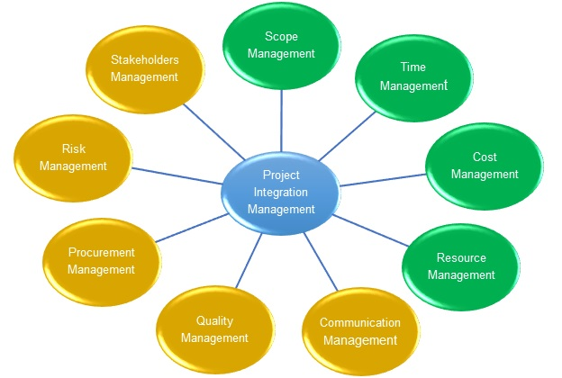

1. Integration
2. Scope
3. Time
4. Cost
5. Quality
6. Procurement
7. Human resources
8. Communications
9. Risk management
10. Stakeholder management

CHAPTER-6

ORGANISATION AND MANAGEMENT STRUCTURE

Organizational structure is a system used to define a hierarchy within an organization. It identifies each job, its function and where it reports to within the organization. This structure is developed to establish how an organization operates and assists an organization in obtaining its goals to allow for future growth. The structure is illustrated using an organizational chart.

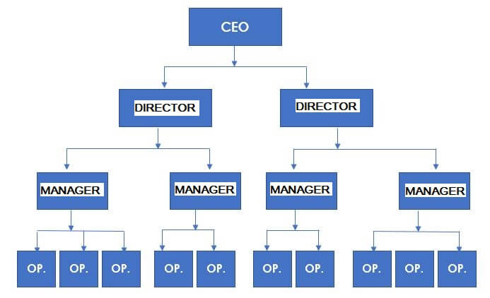

3 common types of organizational structure in project management are:

*Functional organization

*Projectized organization

*Matrix organisation

**Functional Organization :**

All of the companies define its [organizational structur](https://en.wikipedia.org/wiki/Organizational_structure)e to determine the reporting relationships that will exist in the company. It simply states who works for who. Organizations choose their organizational structure based on many factors like: size, its geographic location, the manner of delivering different products and services that they will offer.

A functional organization is the most common type of organizational structure. This is where the organization is divided into smaller groups based on its special functions such as [IT](https://en.wikipedia.org/wiki/Information_technology), finance or marketing. This departmentalization allows greater operational efficiency because the employees have their skills and knowledge to be shared within the group. The basis of this functional organization structure is an arrangement where a worker has different managers for different areas of the organization operation. Since this type of structure has many departments, it could also have several reporting structures as well.

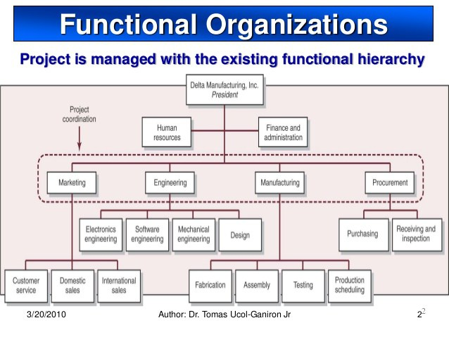

THE PROJECT ORGANIZATION STRUCTURE

A project organization is a structure that facilitates the coordination and implementation of project activities. Its main reason is to create an environment that fosters interactions among the team members with a minimum amount of disruptions, overlaps and conflict. One of the important decisions of project management is the form of organizational structure that will be used for the project.

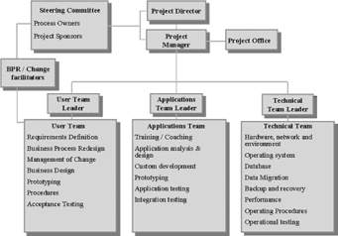

## Matrix Organizational Structure

The matrix organizational structure is a combination of two or more types of organizational structures. The matrix organization is the structure uniting these other organizational structures to give them balance. Usually, there are two chains of command, where project team members have two bosses or managers.

Often, one manager handles functional activities and the other is a more [traditional project manager](https://www.projectmanager.com/blog/project-management-skills). These roles are fluid and not fixed, as the balance of power between these two kinds of managers isn’t organizationally defined.

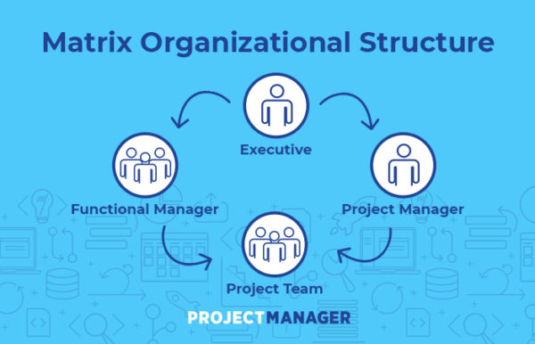

## Use a Matrix Organizational Structure?

The matrix organizational structure is an answer to the problem of [managing large and complex projects](https://www.projectmanager.com/blog/manage-a-complex-project). When working on a large project, a highly hierarchical structure can be an obstacle in the path of moving that process forward successfully.

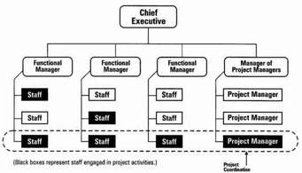

 DO’S AND DON’TS WHEN CREATING A SELF-MANAGING ORGANISATION:

**1. DON'T get angry.**  
"Getting angry is easy. Anyone can do that.

But getting angry in the right way in the right amount at the right time, now that is hard." (Mark Twain) Anger does not belong in your managerial kit bag.

**2. DON'T be cold, distant, rude or unfriendly.**  
Especially in difficult times, employees take cues from their immediate supervisors and need to hear from them.

As such, your team will judge you by your action, moods, and behaviors, not by your intent.

**3. DON'T send mixed messages to your employees so that they never know where you stand.**  
Keep your message simple, focused and prioritized. Too many messages and initiatives just confuse and alienate people.

**4. DON'T BS your team.**  
This includes saying things that you don't believe in. This includes hiding information and just plain lying. By the time each of us is in our early 20′s, we have all developed very well-tuned BS detectors.

**5. DON'T act more concerned about your own welfare than anything else.**  
Your success will come through the success of your team.  
  
"Self-serving detectors" are also very well-tuned in most employees.

**6. DON'T avoid taking responsibility for your actions.**  
You are the boss. As such, you are accountable and the buck stops with you.

You are trying to develop accountability throughout your company. So, lead by example.

**7. DON'T jump to conclusions without checking your facts first.**  
A few years ago, I watched in horror as a colleague of mine started screaming at an employee of his who had missed an important meeting that morning. After several minutes, the employee responded: "I apologize and should have contacted you. But, I just got back from the hospital as my mother has been diagnosed with terminal cancer."

Now here are the dos, which are even more important than the don'ts...

**8. DO what you say you are going to do when you are going to do it.**  
There is no better way to communicate the message that you are accountable for your promises and that everyone in your company should be accountable as well.

**9. DO be responsive (return phone calls, emails).**  
As a manager, your team can be considered to be your customer.  
You want your sales team to punctually respond back to customer requests, so you should do the same.

**10. DO publicly support your people.**  
Your disagreements and disappointment with your employees can be communicated later and in private.

Nothing appears so hollow as your attempt to blame your team for failures.

**11. DO admit your mistakes ...**  
...and take the blame for failures.

**12. DO recognize your team.**  
"You can never underestimate the power of simple recognition for a job well done."

**13. DO ask and listen.**  
"The manager of the future will know how to ask rather than how to tell." (Peter Drucker)

Some of the most dangerous words for a manager to ever say include: "But, you just don't understand…" "Because I said so…"

**14. DO smile and laugh.**  
Have some fun. But, be genuine; programmed fun and faked laughter is worse than doing nothing.

When appropriate, laugh at yourself; it will humanize you.

## 15. DON’T START WITH A PILOT

This seems counter intuitive. Most projects start with a pilot to prove that the concept works. However, in a process like this you end up in a hybrid situation in which people who are not actually part of the pilot are waiting around until they can start too. This creates restlessness. I realize now that we started with a pilot mainly in order to convince others. If we had all started at the same time, there might have been even more lessons learned that we could have benefited from at an earlier stage. It would have also meant less delay to the overall process.

16. **WHEN ALLOCATING YOUR TEAMS, LOOK AT THE GROUP DYNAMICS**

When allocating the teams, we particularly looked at which customers people had in their portfolios and the knowledge and skills available. However, in order to get a team to function properly and to ensure that people are in their element within a group, the dynamic between people is also important. We might have reserved more time for that at the start.

## 17. ACCEPT THAT SOME PEOPLE WILL LEAVE

Not everyone feels at home within the structure and culture of a self-managing organisation or an agile way of working. So be prepared for some people to leave of their own accord ([this example from Zappos](https://www.washingtonpost.com/news/on-leadership/wp/2015/05/08/at-zappos-210-employees-decide-to-leave-rather-than-work-with-no-bosses/) is interesting in that regard). In other cases, it soon becomes painfully clear that certain people do not fit into the new structure.

## 18. KNOW THAT NOT MANY SYSTEMS SUPPORT THIS METHOD YET

Giving all teams access to the same systems and information (without paying out a fortune in licences) is a particular challenge. Suppliers still think very much in terms of roles and the associated privileges. When you try to explain what the idea is, you will notice that this way of working is still far from commonplace. It can also be tricky to explain team activities without getting bogged down in time-consuming administrative processes. In order to support our agile methodology, we use Jira, a kind of to-do list across all the teams. It works perfectly.

## 19. DON’T UNDERESTIMATE THE IMPORTANCE THAT PEOPLE ATTACH TO A ROLE

If you ‘rechristen’ a CTO Performance as ‘Performance Coach’ or appoint your Sales Manager as Sales Coach, don’t be surprised if they aren’t necessarily overjoyed. Employees also appreciate clarity and status, and it is a lot easier to tell someone at a birthday party that you are a Sales Manager with a team of 10 than explaining the role of a Sales Coach who doesn’t directly manage anyone.

## 20. IMPLEMENT YOUR VISION IN DETAIL

A new structure doesn’t just mean that you need to establish new frameworks within which people work. Operating rules are actually very top down. We want to formulate them differently. The same goes for our appraisal system and employment contracts. It is not just a question of what we expect of a colleague, but also what he or she can expect of us. That way, the responsibilities on both sides become clear right away and you start from a much more equal relationship.